**HOTEL MANAGEMENT SYSTEM**

1.PROJECT PURPOSE:

The purpose of this project is to ensure a constant influx of visitors and guests to the hotel throughout the year, and to showcase the wide variety of services and how it benefits the visiting guests through marketing initiatives.

1.2 FUNCTIONALITIES OF THE SYSTEM:

There are 2 modules implemented in our program:

* Admin
* Customer

These are the functionalities of admin module:

* Add room: In this functionality admin can add the rooms.
* Display available rooms: Here admin can display all available rooms.
* Modify the rooms: In this functionality admin can modify any rooms.
* View Customer: Admin can view all the registered customers.
* Search Customer: In this functionality admin can search any specific customer.
* Exit: In this system admin will come out from the system after his task.

These are the functionalities of customer module:

* Register of new customer

Here user must register by giving details like name, address, phone number.

* Book a Room

Once the user has registered then, user will now be connected to the main menu. Once connected to the main menu the user will now be able to book the room as per his requirement.

* Search Room

User can search the room which are available in the hotel.

* Check Out Room

It is the process of customer leaving the hotel by paying the bill and

returning keys to the hotel.

* Exit

This ensures that the customer module program has terminated.

* 1. OPERATING ENVIRONMENT:

SOFTWARE REQUIREMENTS:

|  |  |  |
| --- | --- | --- |
| * Client/Server system * Operating system: Linux * Platform: Ubuntu/C++ |  |  |
|  |  |  |
|  |  |  |
|  |  |  |
|  |  |  |
|  |  |  |
|  |  |  |
|  |  |  |
|  |  |  |
|  |  |  |
|  |  |  |
|  |  |  |
|  |  |  |
|  |  |  |
|  |  |  |
|  |  |  |
|  |  |  |
|  |  |  |
|  |  |  |
|  |  |  |
|  |  |  |
|  |  |  |
|  |  |  |
|  |  |  |

**FLOW DIAGRAM**

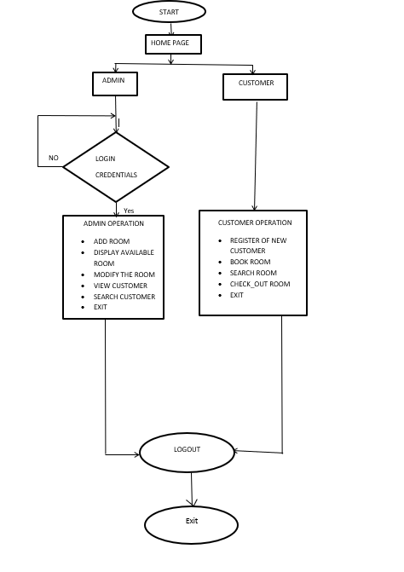

1. **Start**

* This is the start block which indicates the start of the program.

1. **Login Credentials**

* In this module the credentials entered by the user are then validated by the system. If the user or admin enters valid credentials, then it will move to the further step else the system will ask user to register.

1. **Customer module functions:**

* Register of new customer

Here user must register by giving details like name, address, phone number.

* Book a Room

Once the user has registered then, user will now be connected to the main menu. Once connected to the main menu the user will now be able to book the room as per his requirement.

* Search Room

User can search the room which are available in the hotel.

* Check Out Room

It is the process of customer leaving the hotel by paying the bill and

returning keys to the hotel.

* Exit

This ensures that the customer module program has terminated.

1. **Admin module functions:**

* Add room: In this functionality admin can add the rooms.
* Display available rooms: Here admin can display all available rooms.
* Modify the rooms: In this functionality admin can modify any rooms.
* View Customer: Admin can view all the registered customers.
* Search Customer: In this functionality admin can search any specific customer.
* Exit: In this system admin will come out from the system after his task.

1. **End**

* This will ensure the program has terminated.

CONCLUSION:

The conclusion of this project is A Hotel management system is a computerized management system. This system keeps the records of hardware assets besides software of this organization. The proposed system will keep a track of residents, accounts, and generation of report regarding the present status. This project will help in storing, updating, and retrieving the information through various user-friendly menu-driven modules The project “Hotel Management System” is aimed to develop to maintain the day-to-day state of admission/Vacation of Residents. Main objective of this project is to provide solution for hotel to manage most of their work using computerized process. This software application will help admin to handle customers information, room allocation details, payment details, billing information etc. Detailed explanation about modules and design are provided in project documentation. The existing system is a manually maintained system. All the Hotel records are to be maintained for the details of each customer, Fee details, Room Allocation etc. All these details are entered and retrieved manually, because of this there are many disadvantages like Time consumption, updating process, inaccuracy of data. To avoid this, we introduced or proposed a new system in proposed system the computerized version of the existing system. It provides easy and quick access over the data.